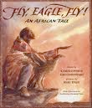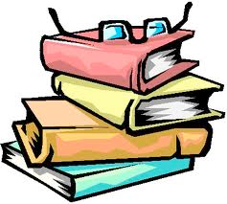

Dear Parents/ Carers,

Thank you for all your support over the last half term. I have really enjoyed getting to know you and your children. They have settled into Year 3 very well, and also completed some brilliant work at school. I am so proud of each of them!

Our main topic for the second half term is ‘Tell Me a Story’ which involves us looking at stories from other cultures. Most of our learning will link in with this in some way and will include reading the beautiful story ‘Fly, Eagle, Fly’. If you are able to send in a story in another language/culture or would like to come in and tell the class a story from your culture, please come let me know!

Please continue to read with your child regularly over the half term as well as practising times tables. Spellings will continue to be given out on a Thursday and reading books will be changed once a week. Please could you help your child to remember to bring their spelling and reading book in every day- it’s very helpful!

I hope you have a lovely break!

Best wishes,

Miss Lennard

Tell me a story...

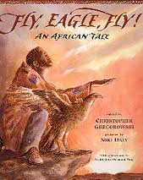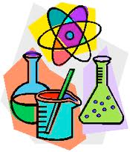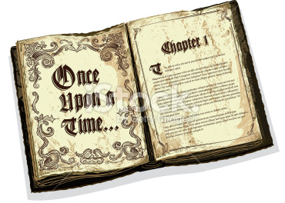

Art and D.T.

* Making shadow puppets using a variety of materials.
* Research puppets and props used in storytelling around the world.
* Create puppets based on this research and the story Fly, Eagle, Fly.
* History:
* We will be looking at the Nigerian civilisation of Ancient Benin. We will be learning about why it is significant, comparing it to other civilisations and investigate what happened to it.

Most of our learning next half term will be based around the book Fly, Eagle, Fly! By Christopher Gregorowsk, as well as looking at the great Nigerian civilization of Ancient Benin.



Tell me a story...

P.E.

P.E. lessons will continue to be on Wednesday and Thursdays/ Fridays next half term.

Wednesday and Thursday/Thursdays- outdoor P.E.

Please ensure your child has correct outdoor P.E. kit - grey jogging bottoms, a red/white t-shirt and a pair of Black or White trainers.

Please only wear PE kits on PE days.

Science

* To continue our topic of light.
* To use our knowledge of light to make shadow puppets.

Geography

* To locate different countries and capital cities from Europe and Africa.
* To compare contrasting locations from around the world.

Literacy

* We will be using Fly, Eagle, Fly as a basis for writing a story with a moral.
* We’ll be using dramatic techniques to get behind the motives and feelings of the different characters and perform our own traditional stories using puppets we have made.
* We’ll be paying special attention this half term to spelling and correct handwriting formations.
* We will be focussing making inferences about characters emotions through our reading.
* We will reading some Haikus, and then writing our own ones.

I.C.T.

* We will be learning about coding using a programme called Scratch.



Numeracy

This term in numeracy class 3 will cover: We will continue with addition and subtraction (including bar models and problem solving). We might then move on to multiplication and division. We will also continue to work on the 4 times tables facts and number bonds to 12.

PSHE:

* We will be thinking about friendship and how we can be a good friend.

R.E.

Our first topic is based around Wisdom and our second is on Advent and Epiphany in the lead up to Christmas.

