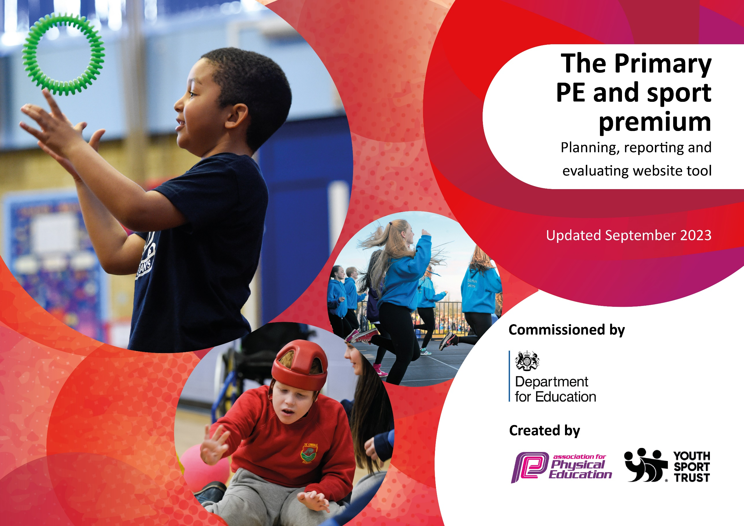

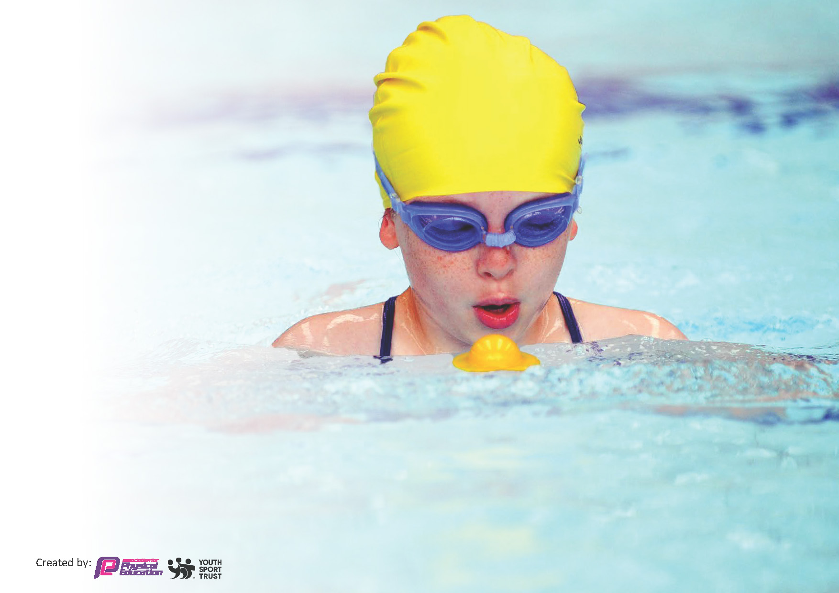
This template can be used for multiple purposes:
by:
- It enables schools to effectively plan their use of the Primary PE and sport premium
- It helps schools to meet the requirements (as set out in guidance) to publish information on their Primary PE and sport premium
- It will be an effective document to support Ofsted inspections enabling schools to evidence progress in Physical Education (PE) and evidence swimming attainment, which forms part of the PE National Curriculum. We would recommend schools consider
the Intent, Implementation and Impact of any spend, as examined within the Education Inspection Framework.

It is important that your grant is used effectively and based on school need.

Schools must use the funding to make additional and sustainable
improvements to the quality of the PE, School Sport and Physical Activity (PESSPA)
they offer. This means that you should use the Primary PE and sport premium to:

- Build capacity and capability within the school to ensure that improvements made now will benefit pupils joining the school in future years
- Develop or add to the PESSPA activities that your school already offers.

The Primary PE and sport premium should not be used to fund capital spend projects; the school’s core budget should fund these. Further detail on capital expenditure can be found in the updated Primary PE and sport premium guidance.

The Primary PE and sport premium guidance, outlines 5 key priorities that funding should be used towards. It is not

necessary that spending has to meet all the key priorities, you should select the priorities that you aim to use any funding towards.

Although completing this template is not a requirement for schools, schools are required to publish details of how they spend this funding. Schools must also outline what the impact this funding has had on pupils’ PE and sport participation and attainment and how any spending will be sustainable in the future. All funding must be spent by 31st July 2024.

The Department for Education has worked closely with the Association for Physical Education (afPE) and the Youth Sport Trust (YST) to develop this template and encourages schools to use it. This template is an effective way of meeting the reporting requirements of the Primary PE and sport premium.
Review of last year’s spend and key achievements (2022/2023)

We recommend you start by reflecting on the impact of current provision and reviewing your previous spend.

Activity/Action | Impact | Comments
Key indicator 1:
All children yr 1-6 know that they need to be active for 60mins a day.  All staff aware of less active children and monitor their activity over the course of each day.  Children to have a voice on lesson / tournament and club provision. | Children talk confidently about their fitness / sporting interest.  Less active children targeted and planned for. Increased participation across these groups.  Every tournament / units of work reviewed by children and results collated and acted upon. | Continue with provision.  Transition – information passed on to next teacher for support to continue.
Key indicator 2:
All members of school family are clear on importance of PESSPA.  Sport has a high profile in school where all KS2 have opportunity to attend sport tournaments.  Sport competition formats make for inclusive competition and increased enjoyment for all.  Achieve Sports Mark Gold to celebrate the role of PESSPA in school. | CPD carried out – teachers and new sports leaders are clear on expectations.  Sport assemblies, newsletters, displays, special activities have kept profile of PE high.  CPD on elements of competition have influenced delivery of inclusive competition – staff are confident.  Achieved – profile of sport / fitness is celebrated and high. | Refresher training each year for teaching staff.  Continue to engage with School Games Programme.  Refresher training each year for teaching staff.  Apply for following year.
Key indicator 3:
All staff trained in teaching progressive skills across a range of sports.  PE Leaders trained in new sports to implement in school. | CPD delivered – teachers feel confident.  Staff learning alongside professionals.  NFL / Tennis training rolled out to yr 4. | Continue with pursuing new sports.
Key indicator 4:
Children understand that sport / physical activity is for everyone and that different sports suit different children.  Parents and children have a raised awareness of clubs and activities in the local area.  Children develop a love of outdoor activity. | Assemblies / questionnaires show understanding.  Clubs organised in response to suggestions from pupils and so numbers in attendance elevated. | Continue to engage children in a wide range of activities.
Key indicator 5:
Using the School Games Approaches to Competition.  All children from yr 3 – 6 to have a positive experience of inter competition. | Children’s reflections show engage well in Forest school  CPD delivered – teachers feel confident.  Children’s feedback / blogs show positive reflections. | Refresher CPD for staff.  Repeat questionnaires and pupil voice across KS2

Key priorities and Planning
This planning template will allow schools to accurately plan their spending.

Action – what are you planning to do | Who does this action impact? | Key indicator to meet | Impacts and how sustainability will be achieved? | Cost linked to the action
Staff CPD to develop:  - Understanding of elements of competition – delivering intra competitions. | Sports Leader – Planning and delivering / attending Borough CPD.  Teaching Staff – attending / carrying out tasks | Key Indicator 1: Increased confidence, knowledge, and skills of all staff in teaching PE and sport. | Teachers’ competency will impact on the development of pupils’ physical activity and engagement. | LYG buy in - £500 – CPD
- Training from professional coaches on lesson structure / progressive skill building.  - Increasing activity within all curriculum lessons | TA sports leader – attending CPD / meetings with sport staff.  Sports Coach – meetings with sports team. | Key indicator 2: The engagement of all pupils in regular physical activity – the Chief Medical Officer guidelines recommend that all children and young people aged 5 to 18 engage in at least 60 minutes of physical activity per day, of which 30 minutes should be in school. | Teachers / support staff / coaching staff are clear on children to target in class / clubs / tournaments to increase engagement – all children will be encouraged to be engaged and meeting the 60 mins target. | Kick sport buy in £1530  – CPD  Sport Leader CPD (cover to attend) and CPD prep time for delivery - £220
- Targeting disengaged / less active individuals. | Lunchtime staff – identifying / encouraging key children to be active. | Key indicator 3: Raising the profile of PE and sport across the school, to support whole school improvement | Children will be more active throughout the day.
- Teachers in situ training for swimming coaching from qualified staff to support swimmers in additional swim lessons on school journey. | After School Club staff - identifying / encouraging key children to be active. | Key indicator 2 -The engagement of all pupils in regular physical activity – the Chief Medical Officer guidelines recommend that all children and young people aged 5 to 18 engage in at least 60 minutes of physical activity per day, of which 30 minutes should be in school. | SEND children will meet key targets on IEPs and engage in competition.
- New sport provider company – Jan ’24 – to increase the focus on using sport to develop the ‘whole child’ through targeted groups. | Sports lead with Sports coach  – to talk through school systems / timetables / equipment / expectations.  TA sports leader – to work with sports coach. | Key indicator 4: Broader experience of a range of sports and activities offered to all pupils. | Children will have a wider experience of Sport e.g. climbing / archery / forest school activities and be signposted to opportunities out of school. | Sport Leader admin / prep time for new staff member CPD - £220
Additional Sporting Opportunities:  - Increase to 3 x fitness / 3 x after school sports clubs.  - Tournament training  - Active kids.  - SEND kids group.  - Play time sport sessions.  - Forest School  - School Journey: Outdoor activities | Sport lead – organising clubs.  School admin – registers.  Sports coach – planning / leading assessing / motivating / introducing new games. | Key indicator 5: Increased participation in competitive sport.  Key indicator 3: Raising the profile of PE and sport across the school, to support whole school improvement.  Key indicator 4: Broader experience of a range of sports and activities offered to all pupils. | All children will have a positive experience of competition / performance / collaboration / teamwork.  Children will experience a love for being active.  Children will experience sporting activities out of their usual experience. | £2664 for staffing for out of hours fitness clubs / sports clubs / tournament training.  Club Equipment: £540  Tennis balls  Basketballs  Volley balls  KS 1Playground equipment: £980 - goals / basketball hoops / soft balls  KS 2 Playground: £ 300 - basketballs  £3060 - staffing for additional SEND / Active kids clubs.
Sporting Events:  - Partake fully in School Games tournaments (all children across KS 2 to attend).  - Wake and Shake: Walk to school day / bring you scooter to school.  - Whole school sports days: EYFS / KS1 / KS 2  - Laban Dance festival.  - Yr 6 Dance performance – Southwark Cathedral  - Platform cricket initiative (yr 4).  - Yr 4 project with Laban Dance students. | Sports coach – coaching for tournaments.  SEND TAs – supporting coach  Forest School lead / TA – trained / planning / leading sessions across whole school.  TA sports leader – team talks / prep.  Sports Leader- booking trips / letters out.  Admin staff – train tickets / lunches.  Parents – attending tournaments.  Governors – attending tournaments.  ECO group / leader – planning walk to school.  Sports Leader – leading wake and shake.  Sports Crew leading warm up.  All staff – taking part / leading events.  Sports lead – dance club.  Sport Leader – organising with sports crew.  Parents – supporting activities.  Year 6 staff.  PE lead – leading / teaching.  Platform cricket staff – leading and training staff. | Key indicator 5: Increased participation in competitive sport.  Key indicator 2 -The engagement of all pupils in regular physical activity – the Chief Medical Officer guidelines recommend that all children and young people aged 5 to 18 engage in at least 60 minutes of physical activity per day, of which 30 minutes should be in school.  Key indicator 3: Raising the profile of PE and sport across the school, to support whole school improvement  Key indicator 2 -The engagement of all pupils in regular physical activity – the Chief Medical Officer guidelines recommend that all children and young people aged 5 to 18 engage in at least 60 minutes of physical activity per day, of which 30 minutes should be in school.  Key indicator 4: Broader experience of a range of sports and activities offered to all pupils. | Children will have a healthy attitude to competition.  Children will develop a commitment to being active and monitor their own activity.  Children will enjoy the experience of performance.  Children will pursue activities and sports beyond school. | Staffing for tournament:  £3200 TA release / cover  Additional PE Lead days:  • Sch journey  • Tournaments  • PE admin for events  £1,100  LYG buy in - £500 – access to LYG tournaments.  Ladywell arena hire £180  Platform Cricket £200  Laban Dance Festival £85  Sport Coach: Training sports crew £88  Sporting spirit medals £11  Sports day stickers £25  Trophies £20  Trophy engraving £10
Sporting Initiatives / Promotion of Sport:  - Training of Sports crew in year 4.  - Gathering pupil voice post tournaments / end of year questionnaire / blogs / sport leader feedback.  - Assemblies promoting fitness (60 mins) / new sports / local athletes / key events such as Olympics / euros.  - Assemblies will promote children’s achievements outside of school to encourage others.  - Sport newsletters.  - Sports board.  - Sporting spirit awards.  - Sports personality of the year award.  - Signposting children to clubs and events outside of school by forwarding sporting opportunities / clubs information to sustain physical engagement. | Previous Sports Crew – interviewing.  Sports coach – training.  Sports lead – organising training materials.  Tournament competitors giving opinions / suggestions/ blogging about experiences.  Sports crew and sports lead leading assemblies.  Sports lead – to organise systems.  Sports TA – to support the blogs / gather pupil voice.  All staff - nominations.  Sports Crew – leading in assemblies / organising activities.  Sports lead – showing videos / organising.  Sports lead – printing photos.  Sports TA – taking photos / preparing for sports board.  Sports lead – copying flyers / flagging up in assembly.  Admin staff – emailing parents. | Key indicator 2 -The engagement of all pupils in regular physical activity – the Chief Medical Officer guidelines recommend that all children and young people aged 5 to 18 engage in at least 60 minutes of physical activity per day, of which 30 minutes should be in school  Key indicator 3: Raising the profile of PE and sport across the school, to support whole school improvement.  Key indicator 5: Increased participation in competitive sport. | Children will develop leadership skills.  Children’s comments will impact future decisions.  Children will feel proud of achievements made in sport and aspire to be like others.  Children will develop a sustained interest in sport.

Key achievements 2023-2024
This template will be completed at the end of the academic year and will showcase the key achievements schools have made with their Primary PE and sport premium spending.

Activity/Action | Impact | Comments
Staff CPD to develop:  • Understanding of elements of competition – delivering intra competitions.  • Training from professional coaches on lesson structure / progressive skill building.  • Increasing activity within all curriculum lessons.  • Targeting disengaged / less active individuals.  • Teachers in situ training for swimming coaching from qualified staff to support swimmers in additional swim lessons on sch journey.  • New sport provider company – Jan ’24 – to increase the focus on using sport to develop the ‘whole child’ through targeted groups. | Teachers are more informed and have led a range of intra competitions using different competition formats to ensure inclusivity – more children feel sport is for them.  Teachers have incorporated physical active / outdoor learning across curriculum lessons increasing children’s activity – children are closer to 60 mins target.  Teachers are clear from transition information and from training, who to target and give additional support to. All children are active across the day.  Teachers target / support non swimmers / SEND during instructor lead sessions to increase swimming target for yr 6.  Sports coach focusses on inclusivity / sport for all. | Refreshing teacher knowledge at start of new academic year.  Continue to develop / challenge the urgency of teaching and focus on non-swimmers.  New sports coach for Sept. to focus on role modelling / inclusivity.
Additional Sporting Opportunities:  - Increase to 3 x fitness / 3 x after school sports clubs.  - Active kids.  - SEND kids group.  - Play time sport sessions.  - Forest School  - Sch Journey: Outdoor activities | Sports clubs have increased in numbers – reaching maximum on some days. A wide range of sport clubs are available to appeal to a wider audience so more children are engaged.  Targeted children have increased with activity throughout week. SEND pupils have received targeted training according to IEPs and experienced tournaments.  Children have spoken of the excitement of forest school / sch journey sports and been signposted to pursue activities beyond school to sustain interest. | Pupil voice about clubs for ’24 /5  Organise transition conversations.  Rerun forest school and school journey.
Sporting Events:  - Partake fully in School Games tournaments (all children across KS 2 to attend).  - Wake and Shake: Walk to school day / bring you scooter to school.  - Whole school sports days: EYFS / KS1 / KS 2  - Laban Dance festival.  - Yr 6 Dance performance – Southwark Cathedral  - Platform cricket initiative (yr 4).  - Yr 4 project with Laban Dance students. | All KS 2 children have experienced competition, working as a team, developing sporting spirits and training for some new sports – ultimate frisbee, New age Kurling.  Children have developed professional dance skills and been signposted to Laban Dance. | Apply for School games tournaments ’24-25 – focus on basketball / netball / cricket and SEND tournaments  Reapply for Laban dance and Southwark  Re institute run a mile with new timetable change.
Sporting Initiatives / Promotion of Sport:  - Training of Sports crew in year 4.  - Gathering pupil voice post tournaments / end of year questionnaire / blogs / sport leader feedback.  - Assemblies promoting fitness (60 mins) / new sports / local athletes / key events such as Olympics / euros.  - Assemblies will promote children’s achievements outside of school to encourage others.  - Sport newsletters.  - Sports board.  - Sporting spirit awards.  - Sports personality of the year award.  - Signposting children to clubs and events outside of school by forwarding sporting opportunities / clubs information to sustain physical engagement. | Children have accessed professional cricket coaching and been signposted to Deptford Dragons and holiday camps.  A group of children have been trained and tasked to promote sport throughout the school.  Children have increased interest in watching sports, watching new sports – climbing / breakdancing / high jump / gymnastic events. They have been inspired by watching sport heros which promotes their engagement in sports.  All children feel they can achieve through changing the competition format.  Children feel celebrated through the sports board / winning medals / sporting spirits / trophies / shields and therefore more engaged in physical activity. | Interview for new sports crew.  Enhance roles of Sports crew – widening responsibility.  Work with Blackheath Rugby club as well as Laban and Platform cricket.

Swimming Data
Meeting National Curriculum requirements for swimming and water safety.
Priority should always be given to ensuring that pupils can perform safe self-rescue even if they do not fully meet the first two requirements of the National Curriculum programme of study
Question | Stats: | Further context relative to local challenges
What percentage of your current Year 6 cohort can swim competently, confidently and proficiently over a distance of at least 25 metres? | 46 % | This data is taken from year 5 assessments.  Additional children (9%- refugees) arrived in year 6 who did not have swim training whilst attending this school.  2 x 25m swimmers left at end of yr 5.
What percentage of your current Year 6 cohort can use a range of strokes effectively [for example, front crawl, backstroke, and breaststroke]? | 46% | This data is taken from year 5 assessments.  Additional children (9%- refugees) arrived in year 6 who did not have swim training whilst attending this school.  2 x 25m swimmers left at end of yr 5.
What percentage of your current Year 6 cohort are able to perform safe self-rescue in different water-based situations? | 71% | All children in year 5 attended safe self-rescue training. Additional children (9%- refugees) arrived in year 6 who did not have swim training whilst attending this school. Water safety assembly led by local swim providers.
If your schools swimming data is below national expectation, you can choose to use the Primary PE and sport premium to provide additional top-up sessions for those pupils that did not meet National Curriculum requirements after the completion of core lessons. Have you done this? | Some | Additional whole class swimming / water confidence sessions provided through School Journey.  We are currently unable to provide the level of staffing to take small groups of children for additional swim lessons with our swim provider.
Have you provided CPD to improve the knowledge and confidence of staff to be able to teach swimming and water safety? | Yes | Teachers learn coaching skills and water safety skills from observing our swim providers delivering sessions and to help support SEND.  Teachers give feedback to our swim providers as to the effectiveness of their provision.  We are not in control of the CPD for the swim providers themselves.

Signed off by:
Head Teacher: | F. Holland
Subject Leader or the individual responsible for the Primary PE and sport premium: | S. Tomkins
Governor: | Philip Ratcliff, Chair of Governors
Date: | 23rd July 2024

